Challenge 1: Getting Started

Part 1:

**1. Imagine asking a friend to meet you at a restaurant. What instructions would a**

**computer program need that your friend would not in order to understand how to get**

**there?**

*A: “In order for computer to understand how to meet my friend I would need to break down the map into smaller pieces by declaring variables, calling functions, call as well x;y coordinates, set the length. By doing this I would be able to point how to get the restaurant ”*

**2. What is the difference between source code and machine code? What does the CPU**

**do? Where are instructions and data stored?**

**A**: *“ Source code is any collection of computer instructions written using human-readable computer language, most of the time just plain text. Machine code is a system of instructions and data executed directly by Computer’s Central Processing Unit (CPU). Otherwords, source code is written by programmers and for programmers and to execute a program the programmer should translate source code into machine code by using compliers .*

*CPU stands for CENTRAL PROCESSING UNIT. It performs the calculations and logic functions of the computer. CPU’s also able to initiate transfer of large blocks of data, read or write data to/from devices, and in general, watch over system functions. CPU’s run programs by fetching instructions and data from RAM, evaluating them, and executing them in sequence.”*

**3. What is an IDE and why is it useful?**

**A:** *“ IDE stands for Integrated Development Enviroment. It brings all of the programmer tools into one convenient place. Todays IDE brings editor, complier, linker, debugger into on place along with project managing tools to increase programmer productivity. The IDE keeps track of all files related to a project and provide a central interface for writing source code, linking files together, and debugging the software. Because the IDE software uses a central interface for writing the code and testing the program, it is easy to make changes to the code, recompile it, and run the program again.”*

**4. What kind of language is Objective-C? Why do you think we use it for making device**

**specific applications? Why wouldn't we want to use an interpreted language for**

**making iPhone and iPad apps?**

**A:** *“ Objective- C is a compiled language . we use this language because it is ready to run, we don’t need a complier on other devices to transfer source code into machine one to execute a program. And its more private and the most important it is much faster…*

Part 2:

Chapter 3: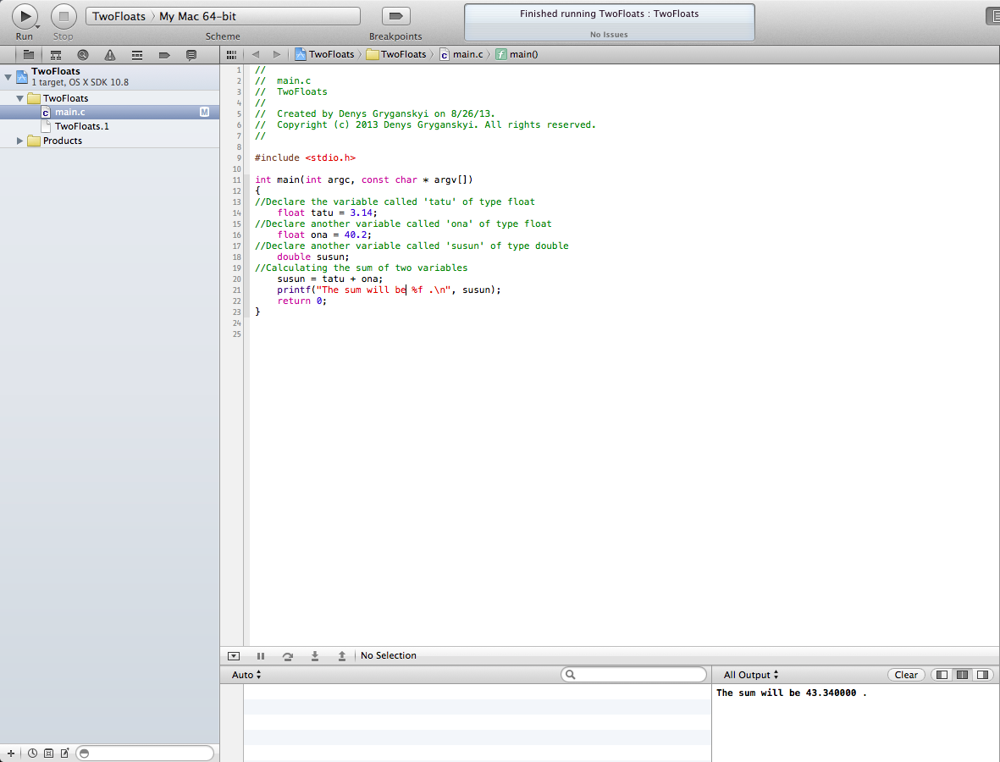

Chapter 4:

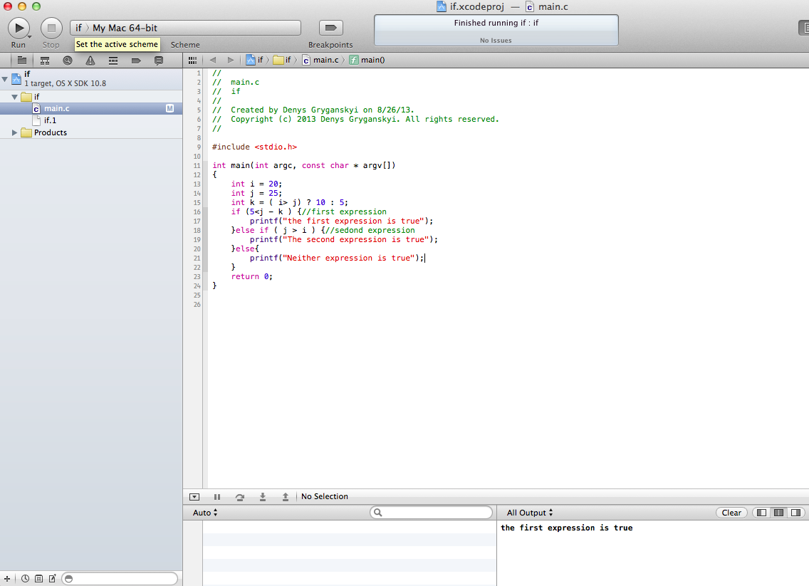

Chapter 5:

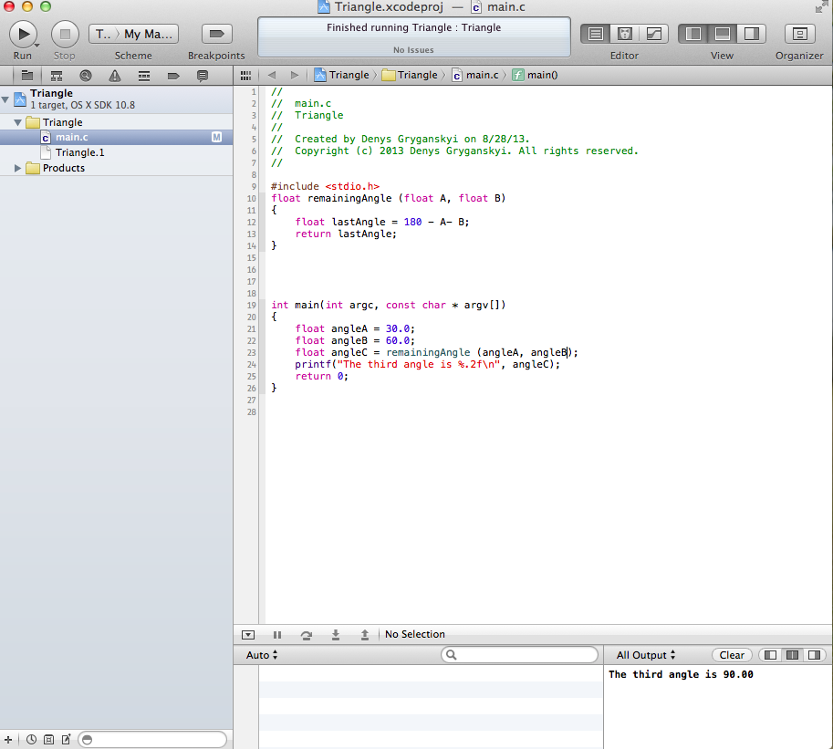

Chapter 6:  
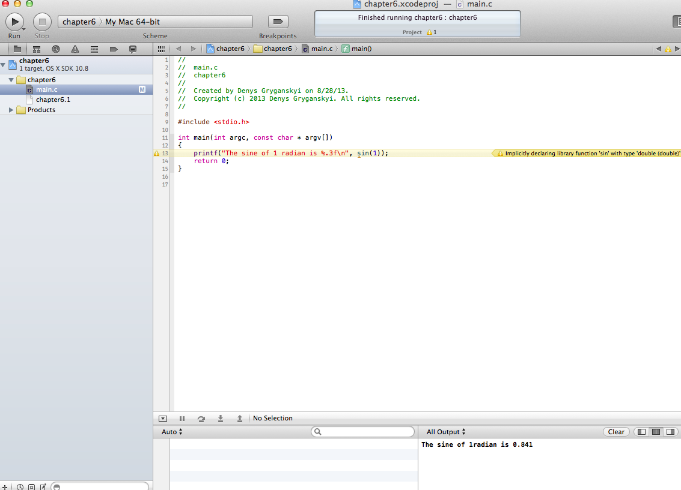

Chapter 7:

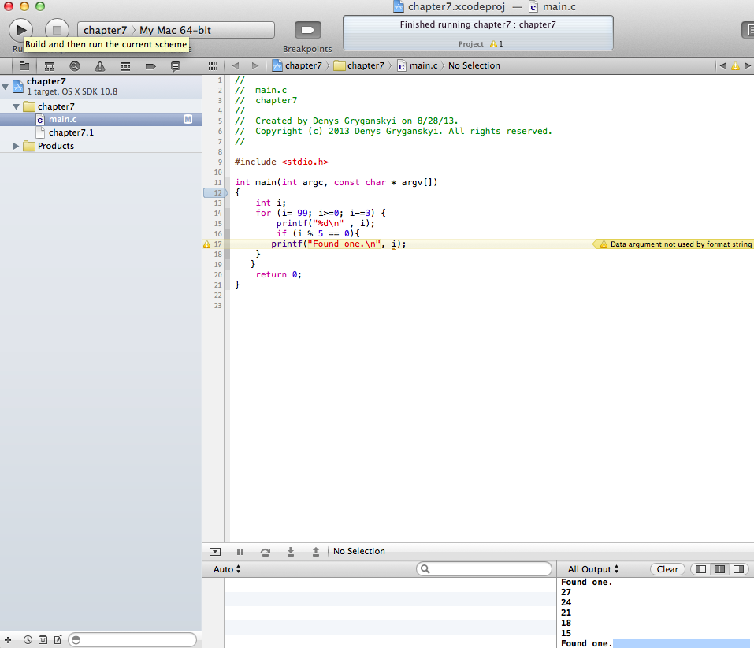

Chapter 10: